# Ahmed ElSory

## Definition

**# Source**: **Chatgpt (GPT-5-Standard) at [8/27/2025]**

Ahmed ElSory is a YouTube channel (run by a creator often referring to himself as "Abu Hamid") focused on gaming content. The channel offers video game reviews, discussions, and commentary that are bold, objective, and engaging. ([YouTube](https://www.youtube.com/%40AhmedElSory/videos?utm_source=chatgpt.com))

## Key Highlights

**# Source**: **Chatgpt (GPT-5-Standard) at [8/27/2025]**

* **Platform:** YouTube
* **Language:** Arabic
* **Content Type:** Gaming reviews, commentary, and game discussions
* **Subscribers:** ~140K
* **Total Views:** 19M+
* **Videos:** ~910 videos
* **Specialty:** Objective reviews and deep insights into gaming topics

## Summary Table

**# Source**: **Chatgpt (GPT-5-Standard) at [8/27/2025]**

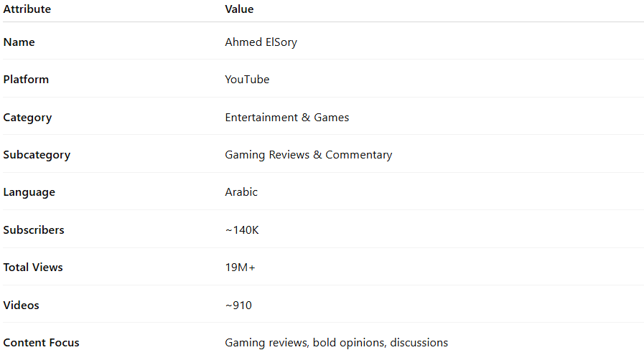

| **Attribute** | **Value** |
| --- | --- |
| **Name** | Ahmed ElSory |
| **Platform** | YouTube |
| **Category** | Entertainment & Games |
| **Subcategory** | Gaming Reviews & Commentary |
| **Language** | Arabic |
| **Subscribers** | ~140K |
| **Total Views** | 19M+ |
| **Videos** | ~910 |
| **Content Focus** | Gaming reviews, bold opinions, discussions |